Guidance for Topic 6 DQ 2
- As always, make sure to enter your name in C2.

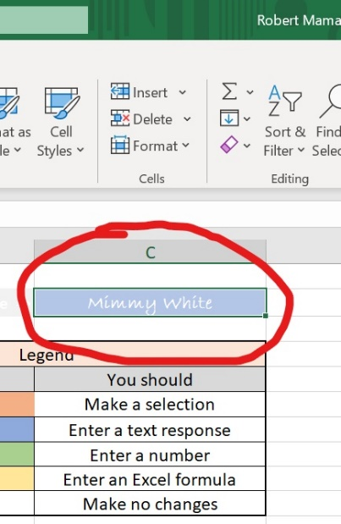

- Once you finish entering your name in C@, the questions that you have to answer appear in column A.

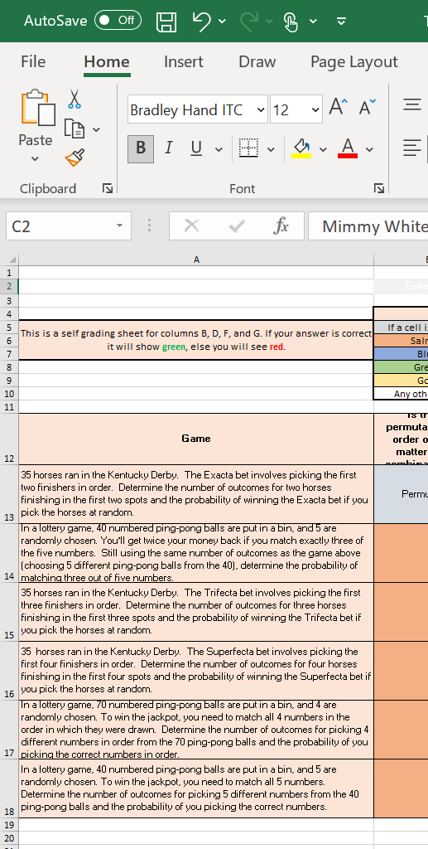
- Note that permutation takes into account the order of choosing while combination does not consider the order. Their difference is explained in this web site: https://www.mathsisfun.com/combinatorics/combinations-permutations.html

- You have to be careful when your question involves the rule of product. It is explained here: https://en.wikipedia.org/wiki/Rule_of_product

Example: Suppose there are 30 balls in total, and there are six correct balls. You pick up four balls at the same time, and you win if you get two correct balls. Now, you have to answer the total number of ways that you can win the game. First, you have to pick two correct balls from six of them, and the number of ways that this occurs is =combin(6, 2). At the same time, you have to pick two wrong balls from 24, and there are =combin(24, 2) ways to choose the wrong balls. The rule of product states that, in total, there are =combin(6, 2)*combin(24, 2) ways to with the game.

